|  |  |
| --- | --- |
| **Practicum Case** |  |
| CPEN6098 | CPEN6108 | CPEN6109  Computer Networks |
| **Computer Engineering** | **O1-CPEN6098-CP01** |
| ***Valid on*** *Even Semester Year 2018/2019* | **Revision 00** |

## Learning Outcomes

* Describe basic structures of network
* Explain concepts of create network environment

## Topic

* Session 09 - DHCP Server Concept & Wireless LAN

## Sub Topics

* Introduction to DHCP Server
* Creating WLAN
* Configuring Wireless Router
* Wireless Security
* Exercises

## Soal

*Case*

1. **DHCP** (**Dynamic Host Configuration Protocol**) **Server** is a one of network protocol based on client-server concept that used to allocate IP address automatically in a network.
2. **WLAN** (Wireless Local Area Network) is a wireless computer network that connecting some supported wireless device within limited area based on radius of wireless device and can extends or give access to wired internal network for some purposes, etc: sharing internet connection.

**Exercises**:

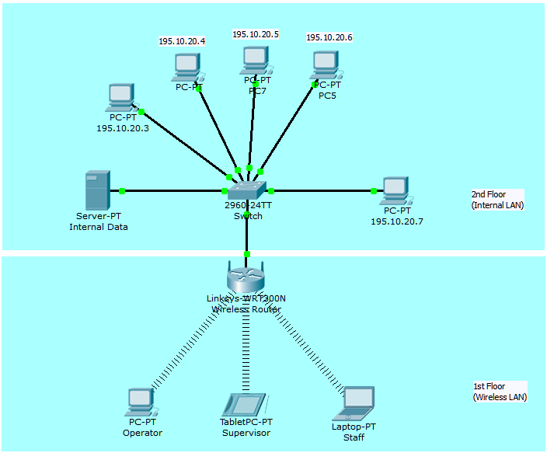

**Big Bang Business Solution** want to build a network that contains Internal LAN for private LAN and **Wireless LAN** to access Internal LAN. Based on that picture, as a network engineer that required to build that network and make all devices can communicate each other’s using **WLAN** and **DHCP Server Concepts**!

**If you don’t understand, please ask to your assistant!**